CHRISTIE ELEMENTARY
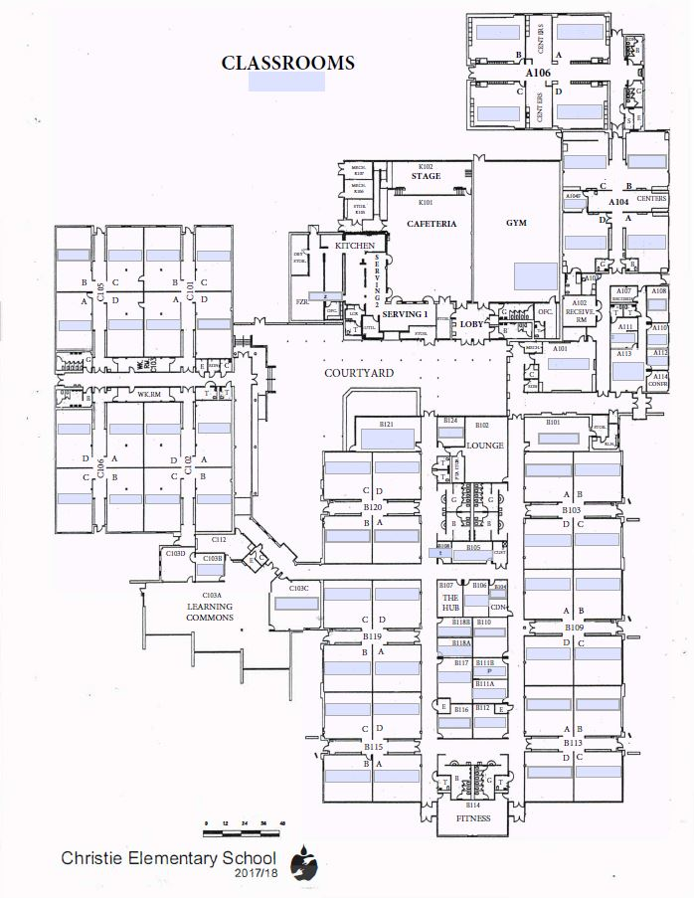
3801 RAINIER ROAD
PLANO, TX 75023
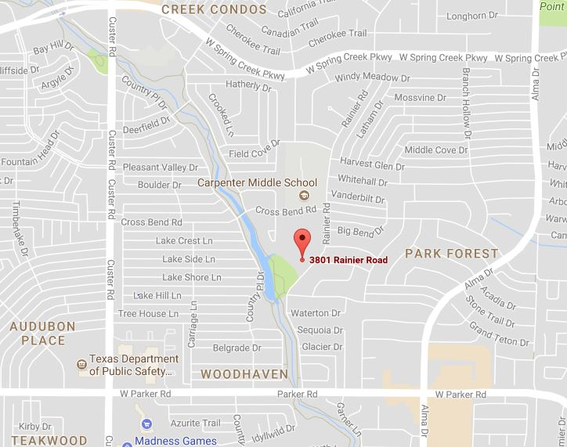

Enter Here

T
E
A
C
H
E
R
S

P
A
R
K
I
N
G

From Parker: Turn on Rainier, heading north. The school is on your left. Take the 3rd entrance and look for signs for drop off.

From Spring Creek: Turn on Rainier, heading south. The school is on the right. Take the first entrance past Carpenter Middle School.
---------------RAINIER ROAD-------------

PCC rehearses here
Tues. 4:30-6:00

Main entrance

